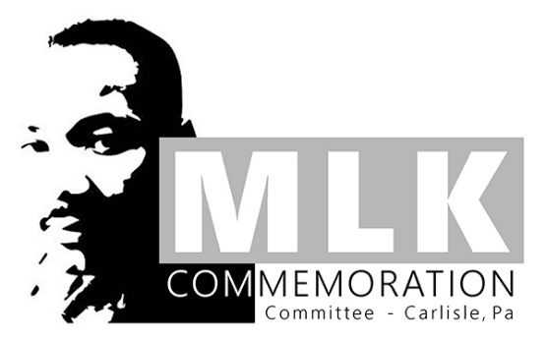
Remember, Celebrate, Act:
It Starts with Me—It Starts with Us!
Rev. Dr. Martin Luther King, Jr.
Project and Showcase
2023-2024
Grades K-12

DEADLINE FOR SUBMISSIONS: JANUARY 1, 2024
(See submission details below.)

Project Prompt:
This year’s theme, “Remember, Celebrate, Act: It Starts with Me—It Starts with Us!,” acknowledges the power of unified action yet highlights the responsibility and potential impact of the individual.
Create a project that explores, expresses, or illustrates this year’s theme, taking into consideration your community (however you define it) as well as the greater life and work of Rev. Dr. Martin Luther King, Jr. Use the following questions to prompt your thinking and guide your work:
- What is the difference between the responsibility and potential impact of the individual versus the responsibility and the impact of a group?
- How did Dr. King’s life and work demonstrate individual responsibility?
- How did Dr. King’s life and work embrace the concept of unity and acknowledge the power of a united initiative?
- Consider at least one goal or vision of Dr. King’s and reflect on where in your community you see evidence of individuals or groups working to achieve that goal or vision. How do these actions demonstrate the potential impact of the individual or the power of unified action?
- Consider at least one goal or vision of Dr. King’s and reflect on where in your community you see opportunities for individual or group efforts to achieve that goal or vision. How could the potential impact of the individual or the power of unified action work to further or achieve Dr. King’s vision?
- Consider at least one goal or vision of Dr. King’s and reflect on how you or a group that you are a part of could initiate meaningful change toward fulfilling that goal or vision. OR, demonstrate the work you are already doing toward that end.

Possible Formats for Project Submissions:
- arts or performance arts projects
- whole-school or all-class initiatives, events, or projects
- social action/social justice projects
- service projects
- videos, essays (analytical, persuasive, or personal), cartoons, short stories, poetry, narratives, letters, multi-media projects, multi-genre projects, personal statements
- Whatever students can imagine, we will welcome!
~ PLEASE SEE NEXT PAGE FOR SUBMISSION PROCESS AND SUGGESTED RESOURCES. ~

Submission Process:

- All entries should be submitted online via THIS FORM.
- If a student completes a poster or other 2- or 3-demensional project (something other than a Word document that can be collected), the student should take pictures of the project and upload them to the form above.
- If a student creates a physical project (something other than a Word document that can be collected), they should also submit the physical piece to their building office as well. These may be displayed at the Commemoration Event on Sunday, January 14 but may be returned to students afterward if desired.
- Some projects will be featured at the Commemoration event. ALL project submissions will be displayed on the Carlisle Area School District website.

Suggested Resources:
Stanford University’s King Institute: https://kinginstitute.stanford.edu/
- Resources for kids: https://kinginstitute.stanford.edu/king-kids
- Resources for students: https://kinginstitute.stanford.edu/information-students
- Resources for teachers: https://kinginstitute.stanford.edu/information-teachers
- Search Documents Feature: https://kinginstitute.stanford.edu/king-papers/search
  - Use this feature to search documents by and pertaining to Dr. King by topic, genre, or date.

MLK Nobel Prize Acceptance Speech (1964): https://www.nobelprize.org/prizes/peace/1964/king/acceptance-speech/

